南京工业大学 计算机图像处理 试题（开）卷B

2018--2019学年 第一学期 使用班级 计1601-4

班级 学号 姓名

|  |  |  |  |  |  |  |  |  |  |  |  |  |  |
| --- | --- | --- | --- | --- | --- | --- | --- | --- | --- | --- | --- | --- | --- |
| 题号 |  |  |  |  |  |  |  |  |  |  |  |  | 总分 |
| 得分 |  |  |  |  |  |  |  |  |  |  |  |  |  |

一、【图像增强】（15+10=25分）

1.一个8级的灰度图的灰度分布如下：

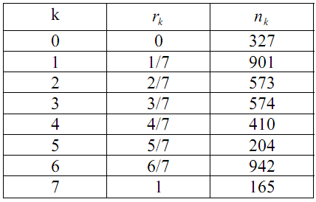

1）画出原始图像直方图；

2）画出直方图均衡化后直方图，并详细写出均衡化步骤。

解：

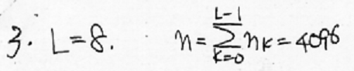

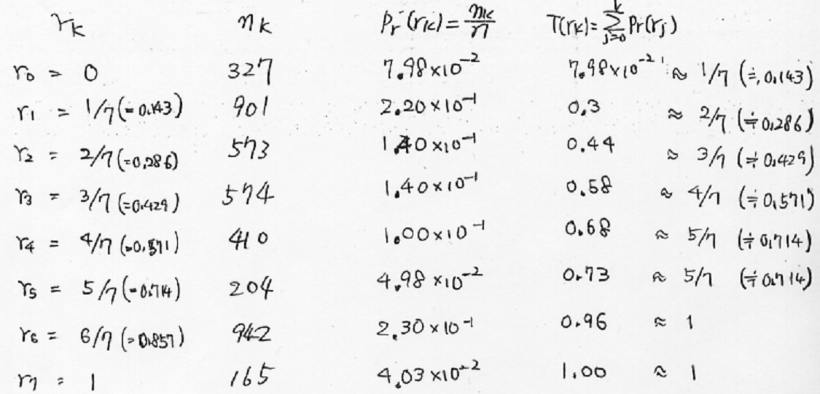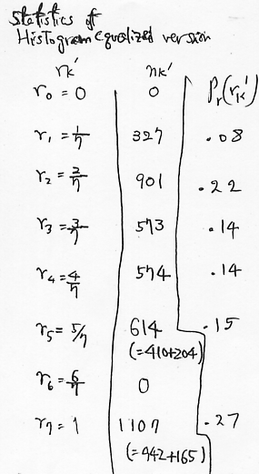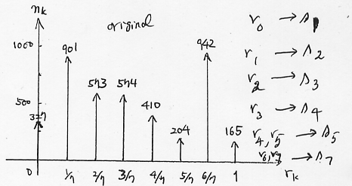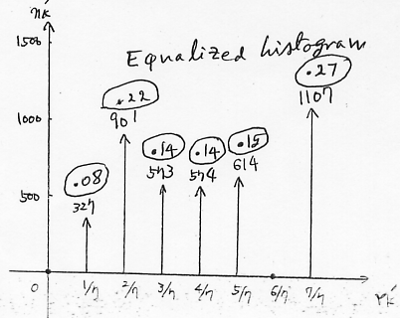

2.中值滤波和空域低通滤波常用于去噪增强：

1）[4 points] Give the name (type) of noise that median filter performs well. And give the name (type) of noise that Spatial Low-pass filter performs wellover median filter.

(B) [16points] Perform [3x3] median filter on the image U given below.

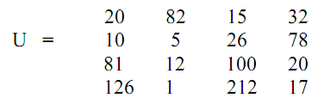

PartA:

Median filter performswell on salt and pepper noise.

Spatial low pass filter performs well on Gaussian noise.

Part B:

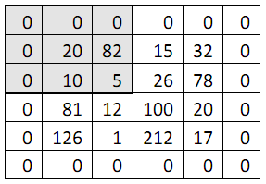

Calculate all median of 3x3 blocksstarting from left top corner. The first 3x3 block is shown as shaded block in the above figure.

Output(0,0) = Median(0 0 0 0 20 82 0 10 5) = 0

Output(0,1) = Median(0 0 0 20 82 15 10 5 26) = 10

Output(0,2) = Median(0 0 0 82 15 32 5 26 78) = 15

Output(0,3) = Median(0 0 0 15 32 0 26 78 0) = 0

Output(1,0) = Median(0 20 82 0 10 5 0 81 12) = 10

Output(1,1) = Median(20 82 15 10 5 26 81 12 100) = 20

Output(1,2) = Median(82 15 32 5 26 78 12 100 20) = 26

Output(1,3) = Median(15 32 0 26 78 0 100 20 0) = 20

Output(2,0) = Median(0 10 5 0 81 12 0 126 1) = 5

Output(2,1) = Median(10 5 26 81 12 100 126 1 212) = 26

Output(2,2) = Median(5 26 78 12 100 20 1 212 17) = 20

Output(2,3) = Median(26 78 0 100 20 0 212 17 0) = 20

Output(3,0) = Median(0 81 12 0126 1 0 0 0) = 0

Output(3,1) = Median(81 12 100 126 1 212 0 0 0) = 12

Output(3,2) = Median(12 100 20 1 212 17 0 0 0) = 12

Output(3,3) = Median(100 20 0 212 17 00 0 0) = 0

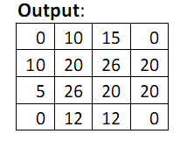

二、【形态学运算及应用】（15分）

1.Propose a morphological procedure to clear the edge artifacts of the image given in (a) such that the image in (b) is obtained. Clearly state the structuring element(s) and number of iterations that you would use in your procedure.

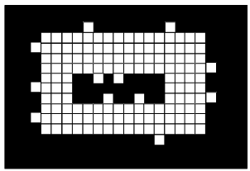 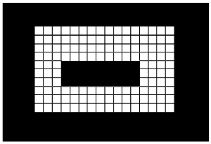

Erosion after dilation (opening) by using the following structuring element will clear the edge artifacts



After erosion by B, the image becomes.

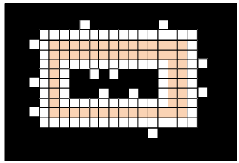  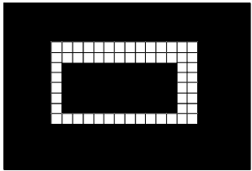

After dilation by B, the image becomes.

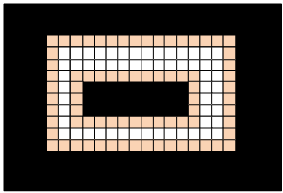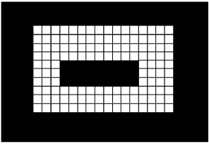

三、【图像插值】（12分）

1.一种实现线性插值的方法是先按行列对原图像进行零插补延拓，然后用插值模板对其做卷积。对于图像数据U, 内插窗口模板H如下，写出执行线性内插的详细过程和结果。

，

解：

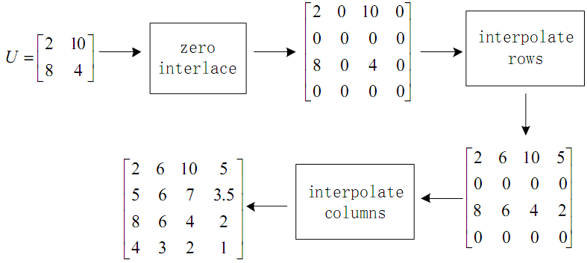

四【Wiener滤波】（12分）

1.Assume that the degradation transfer function in the frequency domain is given below.



Generate the resulting simplified expression of the Wiener filter by assuming that the ratio of power spectra of the noise and undegraded image is constant,

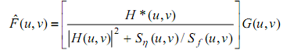







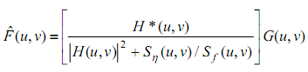

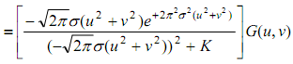

五、【图像特征】（10分）

1.已知二值图像如下：

（1）对该图像使用四叉树进行划分；

（2）用四叉树表达该图像。

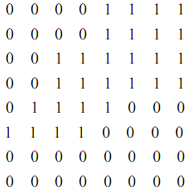

解答：

（1）用四叉树划分如下：

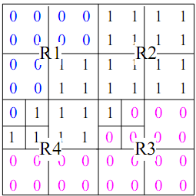

（2）用四叉树表示如下：

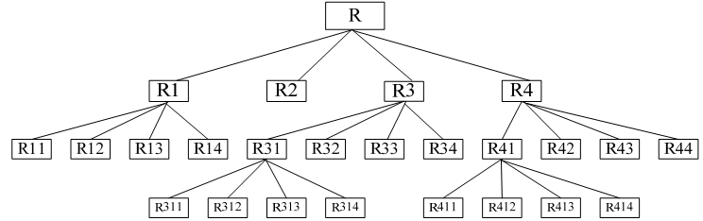

六.【哈夫变换检测圆】(10分)

图像空间 Hough 变换参数空间

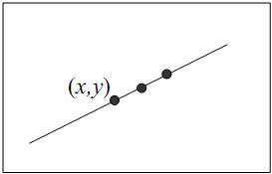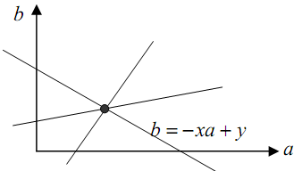

上面两个图，正如课堂上讲过如何用Hough 变换探测直线，一条直线上点 (x,y) 映射到Hough 变换参数空间一条直线b =−xa+y，图像空间中共线的多个点被映射到参数空间相交于同一点的多条直线，该交点唯一决定了原图像空间中的那条直线。现在请拓展这个方法用于图像中圆的检测：

1）首先，写出以圆心(x0，y0)和半径R为参数的方程；

2）类似于直线检测，参数(x0，y0，R)定义了图像空间中的一个圆，同时可以表示为参数空间中的一个点。对于图像中圆上的一个给定点(x,y)，在Hough 变换参数空间找到这样的点，它们对应于图像中所有经过点(x,y)的圆。请问这些点构成什么样的形状？

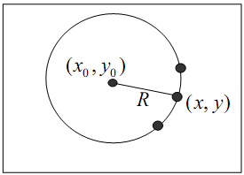  

3）写出Hough 变换检测图像中圆的详细步骤。

7. P.4 (Hough Transform for Circle Detection) (25%)

image space Hough Transform parameter space



We have shown in the class how to use Hough Transform to detect lines in an image. As

shown in the two figures above, a point (x,y) on a line is mapped to a line, b =−xa+y , in

the Hough Transform parameter space. Multiple points on the same line in the image

space are mapped to multiple lines in the parameter space. Their intersection point

uniquely determines the parameters of the line.

In this problem, we want to extend the method to detection of circles in an image.

(a) First, write down the equation defining a circle with center (x0, y0) and radius R in the image space.

(b) Similar to the case discussed above for line detection, parameters

(x0,y0,R) defines a circle in the image space and can be represented by a point in the Hough

Transform parameter space. Now given a point (x,y) located on a circle in the

image space, in the Hough Transform parameter space find the points

corresponding to all of the circles passing the point (x,y). What is the shape

defined by these points in the Hough Transform parameter space?

(c) Describe the step-by-step procedures that use Hough Transform described above

to detect circles in an image.

  

In the real world application, digital image linear interpolation is often done by first

interlacing zeros along rows and columns, second convolving with the interpolating

window, and then taking the middle part of the convolution result to get the image with

the required size.

For the following data: 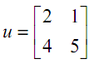,and the interpolating window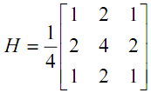.

Show: a), Zero interlaced matrix u’ with the size 4 x 4.

b), Result of , has the size 6 x 6.

c), The resulting data of the interpolation, which has the size 4 x 4.

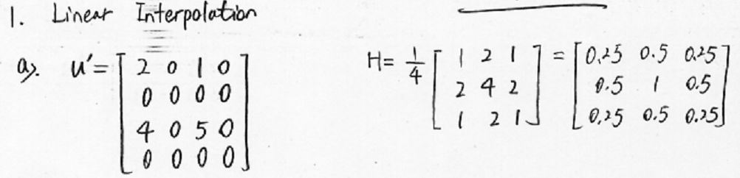

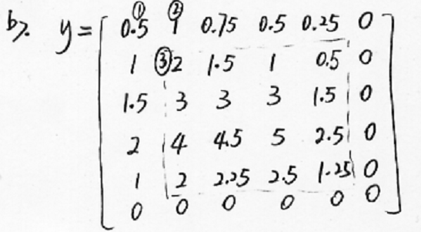

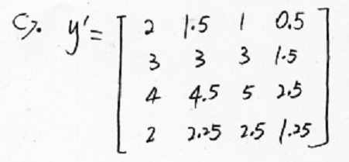

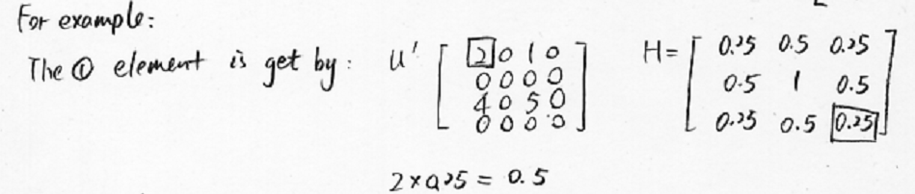

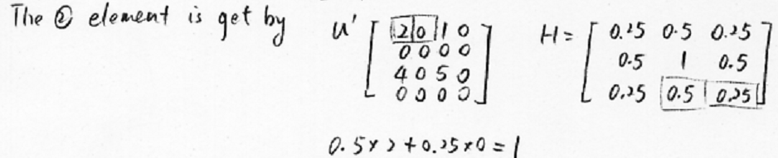

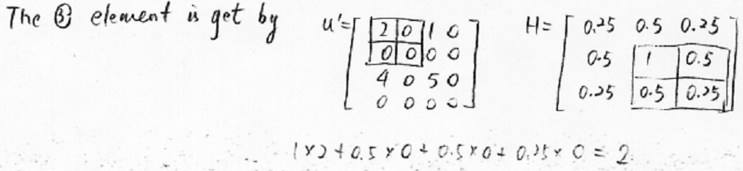

1.对于如下二值图像，图中的粒子都是大小相同半径为r的圆粒子：

1）设计一个处理流程，移除粘连的粒子；

2）为正确计数粒子个数，需要将这些粒子目标进行分割，尤其是对粘连的目标分割，设计一个将这些粒子分割的方法。



解：1）使用与圆粒子大小一样的结构元Bob，再构造一个Bob外围围一圈薄黒环的结构元Bbk

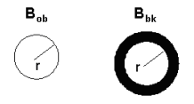

用Bbk做hit-and-miss运算后，只有形状与Bob一致的圆粒子中心会保留，即两个不重叠的圆粒子中心像素得以保留；然后用Bob做膨胀运算即可以恢复这两个分离的粒子，也就是把重叠粒子去掉了。

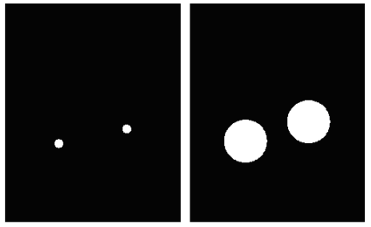

2）对目标做距离变换，能后用分水岭分割方法。